Trenton High School Varsity Crew
Parent/Student Handbook
2019/2020

Rowing - “The sport of gods, that requires constant physical exertion, perfect poise, balance, timing, awareness, brute force, and a sensitive touch” - Author Unknown

Welcome! Congratulations on deciding to become involved with Trenton High School Crew!
Few young athletes discover and develop a passion for this unique sport. Rowing is not a mainstream sport in this country but one that will set your son or daughter apart and benefit him or her in ways you cannot yet imagine. This handbook was designed for new and seasoned parents/student crew members. Hopefully, this information will answer all of your rowing questions you never even knew to ask.
What is the sport called Crew?
Crew (krü) n. 1. a sport practiced in rowing boats where the participants willfully awake before dawn and run to practice where they spend one to two hours sitting on a hard wood seat and pull on oars to such a level as to cause their bodies to go into oxygen debt, resulting in the formation of lactic acid in their blood, which causes substantial pain and discomfort in all major muscle groups. This activity is usually performed twice a day in the name of fun, and is conducted under the demonic supervision of a person called "Coach" with the help of his trained servant named "Coxswain".
The demands of Crew can be overwhelming for both the parent and the rower. It is an expensive sport and can take away much of your free time during the Spring. Fundraising and volunteering become your new career throughout the year. Early morning wakeups and two-a-day practices leave you exhausted. However, Crew is addicting from the friendships that will last a lifetime, the smiles and tears from winning races, and the food. Did we mention the food yet? “Tailgating” at regattas for the parents is incentive enough.
So again, welcome! Enjoy this experience with your family and at the end of the Spring season you will be glad it is over but you will also be saying, “I can’t wait for next season!”
“Rowers… Can do it all, and they can do it well. Joining the rowing team will be the greatest decision you will ever make, if you choose to accept the harsh realities of the sport. By doing so, you will understand the incalculable value of an indomitable spirit-and you will learn, above all, that your achievements in life are limited only by the magnitude of your drive to achieve them.”
~Amy Yao

Safety Comes First

The first question that crosses a parent’s mind when it comes to rowing is, “Will my child be safe?” The answer is yes. Keeping your student safe is a top priority of the head and volunteer coaches.

Before a rower is allowed out on open water, the rower must successfully pass a swim test. The swim test is conducted in a pool under supervision by the coaches and a lifeguard. In addition, the rowers will watch a U. S. Rowing safety video and be instructed by the coaches on other items that may affect their safety.
Will the boats (called shells) tip over? The odds of a shell tipping are fairly low but it does occur from time to time. Most rowers go years, or even their entire career, without having their shell tip over. The shells will float even if they are swamped or filled with water. In addition, coaches are on the water during practices and regatta officials are on the water during regattas to ensure the safety of rowers. Coaches and officials use launches that are fully equipped with PFDs to ensure the safety of the rowers. All coaches are certified in CPR and First Aid.

Typical dangers/injuries include, but are not limited to:

- Blisters- Most common injury for a rower caused by the blades. In the event your athlete develops a blister(s), a sterile needle can be used at the base of the blister to pop it, however, if it does NOT hurt, do NOT pop it. Also, do NOT peel away the blister. Using antibiotic ointment repeatedly to keep it moist while the skin underneath is healing is recommended. Rowers CANNOT use gloves while rowing. They can use bandages/tape on their hands while in the boat.
- Track bites (a.k.a. Calf bites)- Track bites are caused when the calf continuously rubs against the front of the slide. It usually leaves skin rubbed raw and can scab over.
- Chafing- Chafing happens on the rower’s bottom. Chafing happens when extensive rubbing occurs between the seat and the rear end of the rower.

Other possible dangers/injuries include, but are not limited to:

- Hyperthermia
- Hypothermia
- Dehydration
- Ejection from a boat (VERY rare but called an ejector crab)
- Minor cuts/bruises from improper handling of equipment
- Dangerous conditions existing during high winds, lighting, and extreme heat or cold

Rowing Preparation and Competition

Rowing athletes spend as much time as possible throughout the year preparing their bodies and minds for their competitive rowing season. When practice on rivers and lakes cannot occur, indoor and outdoor conditioning and practice is encouraged. Rowing clubs (athletes from more than one school competing as one crew team) and universities in the United States and Canada have at least two competitive seasons, one in the fall and one in the spring. Many also participate in a summer season. In Michigan, spring is the official competitive rowing season for high school crews.
Winter conditioning is not mandatory but is highly encouraged for students who are currently not participating in in other school sports and wish to prepare for the spring rowing season. Winter conditioning will begin on December 1, 2019 and are usually held 5 or 6 days per week. The practices usually alternate between Trenton Public Schools (TPS) facilities and Wyandotte Boat Club (WBC) facilities. Winter conditioning focuses on erging (rowing machine), indoor rowing simulation (rowing tanks), weight training (weight lifting equipment), and cardiovascular endurance (indoor and outdoor running). No outdoor rowing occurs during winter conditioning.
Crew Spring Training Camp is not mandatory but is highly encouraged. Spring training has been proven to be a very effective training tool (especially for novice rowers) since it gives rowers concentrated time to row. Attending Spring Training Camp gives rowers an opportunity to condense several weeks of on the water training sessions into just one week. Most high school rowing clubs and teams attend spring training camps in preparation for the competitive season.

The 2020 Crew Spring Training Camp will take place Saturday, April 4 through Friday, April 10, 2020 in Oakridge, Tennessee.

Spring Competitive Season usually begins on a Monday in mid-March and ends at the Crew Banquet which usually takes place on a Wednesday in early June.

The spring 2020 Competitive Season will begin on Monday, March 9, 2020.
Crew Practices take place throughout the entire Spring Competitive Season from mid-March to early June. All practices are MANDATORY whether its morning, evening or Saturday. It is important for your schedule to remain as flexible as possible.
Regattas usually take place on Saturday’s mid-April through early June. Regattas are held at the Wyandotte Boat Club as well as other locations in Michigan, Ohio, and Canada. A schedule of regattas is usually completed and published in January/February.

Crew Practices
The following information is for general purposes only. All practices are held at the Wyandotte Boat Club (WBC) unless otherwise stated. All student athletes are expected to arrive on-time, quickly position equipment, and be ready to begin practice as directed by the coaches. Practice schedules may change from week-to-week or day-to-day depending upon weather, regatta schedules, and/or other unforeseen circumstances.

Regular Practices take place during the entire Spring Competitive Season. Practices are held in the mornings or evenings on weekdays and on Saturday mornings of weekends without regattas. The coaches will determine practice schedules by boats. They will send out the practice schedules weekly. Every effort is made to start and finish practice at the stated time, however, there are occasions when practice times and/or days need to be adjusted because of unforeseen circumstances.

Morning Practices usually occur on weekday mornings for one-hour before school and usually take place from 6:00 am to 7:00 am. The whole team doesn’t attend morning practice every day. The student athletes that are invited to attend morning practices are selected by the coaching staff. Morning practice schedules are sent out weekly to allow the rowers to plan their week accordingly. Morning practices are scheduled to allow all rowers to be dismissed from morning practice with ample time for them to arrive at school on time. However, the WBC is home to six other downriver high schools and at times the docks can be congested. This could cause a delay getting crews off of the water. All crew members should pack a breakfast to eat to avoid being late to school. Parents, please enforce this with your student athlete. Student athletes are expected to go directly to school after morning practice. Stopping for breakfast after morning practice is NOT an acceptable reason for a school tardy. Additionally, optional practices may also be offered on Sundays.

Attendance of all Crew members at regular practices and regattas is critically important to the success of the team and the enjoyment of crew for all team members. Rowers and coxswains are expected to attend all required practices and regattas throughout the entire Spring Competitive Season. Arriving to practice on time is crucial. With limited daylight hours, the rowers generally go out on the water soon after practice begins. Once rowers are on the river they do not come back to pick up a rower who is late unless it was pre-arranged and approved by a head coach. It is important to understand that rowing is a sport where each boat requires a specific number of rowers and one usually one coxswain in attendance. If one of the rowers or the coxswain is absent the others may be unable to practice. Rowers or coxswain who miss practices during the Competitive Racing Season may lose his or her seat in the boat and not be able to race in regattas. Once on the water, it is difficult to get individuals back to the dock early and if practice is on land it is disruptive to the rest of the team for student athletes to leave early. Leaving early from practices should be avoided, and should only occur if prior permission is granted by a head coach.

Crew members must text their Head Coach: Jeff Taylor (734) 771-6795, no later than 24 hours before the start of a practice to inform the coach about the anticipated absence.

Cost Summary
The $130 Trenton High School Activity Fee must be paid to Trenton High School BEFORE the student participates in the first official Trenton Varsity Crew practice of the season. Students will NOT be able to participate until this activity fee has been paid.
In addition to the THS Athletic Activity Fee of $130, there is a Crew Participation Fee of $400 for each crew member.
The $400 Crew Participation Fee is broken down into two parts:
- The first part is the $100 Commitment Fee which is due on March 1, 2020. The Commitment Fee is refundable if requested in writing prior to March 31st of the school year in which it was paid.
- The second part is the remaining balance of the $300 and has been broken down further into payments with specified due dates. The remaining balance payments are NOT refundable.
Students will NOT be able to participate until the THS Activity Fee and the Commitment Fee have been paid.

Both the $100 Commitment Fee and the $300 remaining balance of the Crew Participation Fee are paid to the Crew Booster Organization and pay the costs (equipment, regatta fees, transportation of equipment, etc.) of the high school rowing program at Trenton High School other than coach salaries and varsity letters and pins. Please see the Trenton Varsity Crew Payment Coupon Handout for more information regarding payment amounts and due dates.

There is also a $500 cost for Spring Crew Training Camp held April 4-10, 2020 in Oak Ridge, Tennessee. Although Crew Camp is not a mandatory camp, it is highly encouraged. There are only 50 spaces available for students wishing to attend camp given seating capacity of the motor coach. Opportunities will be provided to Crew Members and their families to offset some or all of the Crew Camp Fee through fundraising. Please see the FUNdraising section of the handbook for more information.
Rowers/coxswains will NOT be allowed to practice, attend camp, and/or compete in regattas if the THS Athletic Activity Fee, Commitment Fee and/or Participation Fees are not received by their due dates as indicated by the Trenton Varsity Crew Payment Coupon Handout.

Send Payments to: Joanne Bulatovic, Treasurer
1561 Edsel
Trenton, MI 48183

***Please make out checks to Trenton Public Schools or TPS
***Please write student’s name and grade on the check and include the correct coupon(s).

FUNdraising
FUNdraising is the heart beat of the operation of THS Varsity Crew. THS Varsity Crew does not receive monetary support from THS or Trenton Public Schools other than paying coach salaries and providing varsity letters and pins. In an effort to keep participation fees affordable, THS Varsity Crew relies on FUNdraising to cover expenses, repairs and purchases of equipment.
We need to raise the funds to support the annual operating expenses and equipment purchases. Rowing is an expensive sport and FUNdraising is essential. A “shell” or boat can cost $10,000 to $45,000.
We strongly urge everyone to participate in the FUNdraisers. Why? Because we are a Crew Family. Participation in the FUNdraising activities throughout the year establishes a bond and allows families to share unique experiences which are increasingly valuable between teens and parents today.
A few of the FUNdraisers that THS Crew participates in throughout the year are Scrap/Bottle Drives, Trivia Nights, Painting Parties, and selling items such as Butter Braids and Little Caesars Pizza Kits.

The funds raised benefit every member of the Crew and therefore we need every Crew member to do their part of the FUNdraising. We expect that Crew members volunteer their time and efforts in support of as many of the THS Crew FUNdraisers as they are able. We understand that everyone is busy and there may be FUNdraising events that Crew members and their families cannot assist with from time to time. That is to be expected and not a problem. What we are trying to avoid is having the same handful of Crew members and their families participating in all the FUNdraisers all of the time while other Crew members and their families participate very little or not at all.

Volunteering
The only way to make THS Varsity Crew successful is by parent volunteers like you. There are thousands of hours that go into the rowing season and as a rowing parent, you must be involved.

Regatta Coordinator: Tammy Cullen / Vince Pattenaude | Food Coordinator: Patrick Stapleton
Banquet Coordinators: Lori Baleczak | Bottle/Scrap/Metal Drive Coordinator: TBD
Ad Sales Coordinator: TBD | Sign Up Genius Coordinator: Susan Truitt
Uniform/Spirit Wear: Tanis Hodge | Fundraising Coordinator: Tammy Cullen/Kristen Zanetti
Butter Braids Coordinator: Jen Keller | Camp Coordinator- Kristine Irvin
Team Dinner Coordinator for each class | Freshman: TBD
 | Sophomore: TBD
 | Junior: TBD
 | Senior: TBD

Clothing/Uniform
Clothing and Gear for Practices: For all practices athletes should have a gym bag with clothing and gear for practices in all types of weather and for all types of possible practices.

- Spandex shorts with inseams that are at least three inches long and do not look like undergarments
- Shorts for over spandex for running and/or weightlifting if desired
- Comfortable shirt that is not too long
- Running shoes
- Slide sandals or crocks for on the dock
- Socks and extra socks
- Long Sleeve Shirt
- Sweat Pants
- Sweatshirt
- Hat
- Water Bottle

If any coach feels that clothing is inappropriate, the rower may be asked to change. Remember, your child does not know for certain whether they will be inside or outside on any given day so they need to be prepared! Some kids are self-conscious in the beginning about wearing spandex but anything else is likely to get caught in the seat mechanism of the boat when they are rowing. This is also the reason for not wearing shirts that are too long. If shorts/shirts get caught in the slide, the rower’s clothes may have to be cut off of them to get them out of the boat.

Uniform for Regattas: The THS Varsity Crew Uniform must be worn for all regattas. This includes, at a minimum, the spandex shorts and racing tank. The racing tank is provided by Trenton Public School and issued each year to Crew members. The racing tank must be returned at the end of the season or the student/parents must reimburse Trenton Public Schools for the cost. Rowers must provide their own spandex shorts. An additional long sleeve top may be purchased by the student/parents and worn underneath the racing jersey. Additional uniform pieces may be purchased through Sew Sporty (spandex, long sleeve, jacket) or Spirit Wear sites. The Sew Sporty Store will be open in January to purchase items. The Spirit Wear Store will be open in late fall (just in time for Christmas presents) and again in late winter/early spring. Reminds and emails will be sent out when the stores open up.

Required Documents
A physical and concussion form must be one file with the THS Athletic Office prior to participating in any winter conditioning or practicing with the Crew.

For All Regattas: A valid THS Student Identification Card must be presented to the regatta official by each student athlete prior to participating in a regatta. The rower must have their student ID in order to row!! NO EXCEPTIONS. Sometimes IDs get lost, misplaced or forgotten. To ensure your student has their ID on race day, all rowers are required to get an extra ID from the THS Counseling Office (cost is $5). At the regattas, ID will be given to the coach and/or designee to be placed on a lanyard that will be given to the rower on race day to wear around their neck and returned immediately to the coach after the regatta.

For Canadian Regattas: For all travel to Canada, the rower/coxswain will be required to have a birth certificate, or passport, or Enhanced Driver’s License. Student athletes must also bring a notarized permission form. Adults need a passport or Enhanced Driver’s License to cross the border.

Transportation

Unless otherwise stated, parents and/or students are expected to provide transportation to all winter conditioning, optional morning or weekend practices, regular practices, and local regattas. Unlike other varsity sports, Crew does not use the THS buses. We use charter buses because we are traveling out-of-state and/or internationally. We may also rely on the parents to get the rowers to and from crew activities and events. Please make sure to fill out the ichat forms as soon as possible so that you will be allowed to drive your child as well as others. The ichat form must be accompanied by a copy of your driver’s license, car registration, and car insurance and turned into the THS Athletic Office. Carpooling is the way to go!! If you cannot make the regatta, we will find a place for your rower.

Regattas for Rowers

Regattas are NOT optional. You should plan your calendar around the regatta schedule. At the start of each season, rowers are responsible for letting their coach know if there is a regatta in which they cannot participate. This is important because each boat has a seating line-up. Rowing is a big commitment and dominates approximately seven (7) consecutive weekends. It is understood that there will be family and medical emergencies that arise. If you cannot attend a regatta, or can’t row due to an injury, notify your coaches immediately. Don’t back out at the last minute, letting your whole boat down! Deadlines for entering line-ups are scheduled weeks before the event, and making changes is difficult. Sometimes boats have to be scratched, and this means the other rowers in the boat may not get to participate because of the conflict of one rower.

Waivers: Throughout the year you will be asked to sign waivers before rowing in a particular regatta. These waivers are required by regatta organizers and are needed to participate. As soon as we have the waiver we will send it to you by email. Some of the waivers are done online. When you receive a waiver email there will be clear and specific instructions to follow. A waiver MUST BE SIGNED in order to row in the regatta.

Food: Trenton Crew will provide food at the Regatta tent for the athletes and coaches only as part of their regatta fees. We will need volunteer parents to set up and break down food tents at regattas and work in the food tent. A sign up will be sent out before the regatta. Parents, siblings and friends can eat for just $5 per person for each regatta. Please make an attempt to sign up and pay in advance, as this will help with meal planning. This is completely optional. Feel free to bring your own food/beverages.

For some regattas, rowers/coxswain may be asked to bring a bag lunch and/or money to stop for food. St. Catherine’s and other selective regattas will have separate food and lodging costs which are the responsibility of the student athlete.

All rowers must stay with their team during the regattas. Throughout the day, we will send down fresh fruit and healthy snacks for the rowers. Lunch/dinner will be served to them following most regattas. Sending additional snacks with your rower is important. All snacks need to be healthy to ensure a great quality performance by your rower.

Crew Member Regatta Packing List

Uniform
Personal water bottle
HEALTHY snacks
Sunscreen
Bug spray
Sunglasses and/or hat
Dry change of clothes (SOCKS)
Sweatshirt or jacket
Towel
Plastic bag for wet clothes
Extra clothes to change into afterwards
Hats/gloves in early spring
Folding chair
Blanket
Money for Food on the way home or a T-Shirt

Regattas for Spectators

- Prepare yourself and your rower for all types of weather. Hats, gloves, blankets, etc. Layers are the best!
- Binoculars are strongly recommended.
- Camera- Taking pictures of the rowers in motion on the water may come out blurry. There is usually time after the regatta for team photos. If you can get close enough, going out and coming in from the water are great photo ops. A CD will be provided to each rower at the end of the season from pictures gathered from parents throughout the season.
- Wear comfortable walking shoes and pack the flip flops. Sometimes the walk to the regatta viewing area/grand stands can be quite a hike and not always paved.
- Chair
- Umbrella
- Sunblock
- Loud cheering voice and a cowbell if you have one. The louder the better!!

No Spectator Zones

As proud and happy as you will be for your rower, don’t approach them after the race. They have a meeting with the coaches afterwards. Also, take care to stay off of the docks. This is not a good place for taking pictures and it can be very slippery. Lastly, please allow the Crew members to concentrate while they are rigging and derigging the boats.

Rowing Terms and Commands

Learning and understanding rowing terms and commands is like learning a new language. This section should give you enough knowledge to make you sound like an old rowing pro. Please take some time to become familiar with them. If you don’t remember all of them, don’t worry, someone is always around to answer your questions.

The Boat (Shell) -There are two types of boats or shells used in rowing, sweep boats and sculling boats. In sweep rowing, each rower uses only one oar. In sculling, the rower used two smaller oars, or sculls. Sweep boats can have two, four, or eight rowers. Sculling boats have one, two, or four rowers. Each boat may or may not include a coxswain, the person who steers the boat.

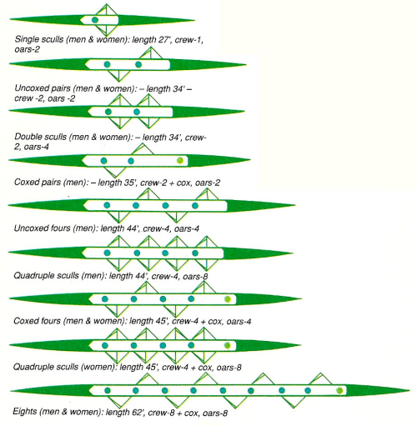
Each boat has a seat or position for each of its rowers. A rower rows either port (left) or starboard (right), depending on which side of the boat his or her oar extends from. Once a rower is assigned a port or starboard position, he or she will almost always continue to row on that side of the boat for the rest of the season, however, this is up to the coaches. For purposes of balance and to avoid oar interference, boats are rigged with an alternating pattern. The standard rigging starts at the bow on the starboard side. It ends on the port side. Based on observation and evaluation of ergometer tests, coaches must determine the best position for each rower. Putting together the boat is probably the number one concern of coaches early in the season. The rower may sit in several boats with different rowers until the coaches have “set” the boat. Many boats, once set, are rarely altered. The rowers in seats 1 and 2 are known

Rowing Terms and Commands (continued)

as the bow pair. They are expected to deliver a smooth fluid technique. In an effort to keep the bow up in the water, the bow pair are usually a little smaller and lighter than the other rowers. They are the first to cross the finish line. Rowers in seats 3, 4, 5, 6, are known as the engine room. These rowers are expected to provide the strongest and hardest strokes. Rowers in seats 7, and 8 are known as the stern pair. They are expected to provide both strength and technique. Seat 8, known as the stroke, sets the pace. It is his/her stroke that the other rowers follow. The coxswain, who usually sits in the back, is the only person with eyes front. The coxswain does not row but rather steers the craft, directs the pace and verbally encourages his/her crew to perform to the best of their ability. Coxswains do not contribute any propulsion to the boat. For this reason, they are usually small people with big vocal chords. A coxswain can be male or female and compete with crews of the opposite sex in their division. See the diagram below. You can clearly see how EVERY seat counts in winning a race. They are a team.
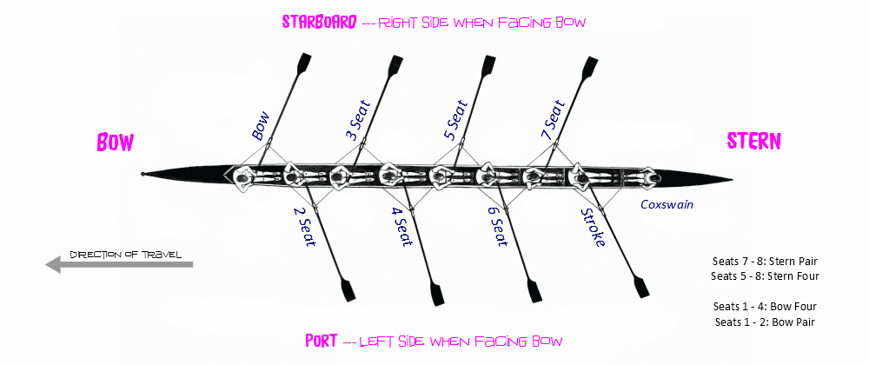

Each race in a regatta is 2000 meters. Depending on the course, there are normally 6 lanes for each race. When there are more than 6 entries for a race then heats must be run first to determine which boats will race in the finals. In most regattas, the finalists are determined by heat placement and/or time.

For example: There are 18 boat entries for the Men’s 4+. There would be 3 heat races. First place from each heat would advance to the finals and the top 3 fastest times thereafter.

Advancement into finals can vary from regatta to regatta.

Definitions

Shell Terms:

Single - one rower with two oars (scull)
Double - two rowers, each with two oars (scull)
Quad - four rowers, each with two oars (scull)
Pair - two rowers, each with one oar (sweep)
Straight Four - four rowers, each with one oar (sweep)
Four With - four rowers, each with one oar and a coxswain (sweep)
Eight - eight rowers, each with one oar and a coxswain (sweep)

DIRECTIONS IN A BOAT:
Stern - the back end of the boat
Bow - the front end of the boat where the bow ball is located
Port - the left side of the boat from the coxswain's view; the right side from the rower's perspective as the rower is facing the stern
Starboard - the right side of the boat from the coxswain's view, the left side from the rower's perspective.
The coxswain always faces the direction the shell is going while the rowers face the rear.

THE BOAT:
Hull - the actual boat. The hull is very thin and fragile. It scratches and can be punctured easily. Be especially careful when moving the boat, always listening to the commands of the coach and the coxswain. NEVER step over the hull; always walk around.
Decks - there are both stern and bow decks on the shell. These decks form compartments to trap air for flotation in the event of swamping or flipping.
Vents - There are vent hatches in both the bow and stern decks. When closed, they trap air; when open they allow air flow to dry out any moisture in the fore and aft compartments. It is the responsibility of the coxswain and bow seat to close the deck vents. There are often vent hatch covers under the seats also. These allow access for adjustments to the seat tracks.
Gunwales - these are the top outer edges of the boat. A lifting point
Keel - runs the length of the hull, down the center, for structural support.
Ribs - run perpendicular to the keel, against the hull, for structural support. A lifting point.
Seat - on wheels that allow forward and back movement. Also, a rower's place and # in the boat.
Tracks - guides in which the seat wheels roll (also called slides).
Foot Stretcher - adjustable plate to which the shoes are attached, allowing adjustment for length.
Strip (Foot Pad) - space between the front of the tracks that is the only place you step when entering the boat.
Rigger - metal or composite "arm" attached to the exterior of the boat that holds the oar.
Oarlock - "U" shaped plastic part in which the oar is placed.
Gate - screw-down rod that keeps the oar from coming out of the oarlock.

OARS:
Shaft - the long straight main section of the oar; usually composite.
Spoon/Blade - the flat part of the oar that enters the water. Either hatchet shaped or, in older oars, tulip (Macon blades).
Handle - the oar part you hold on to; may be wood or composite with rubber grips.
Sleeve - plastic plate about 2/3 up the shaft that goes in the oarlock.

Collar - plastic piece attached around the sleeve that is pressed against the oarlock keeping the oar in the proper place.
Clam - a clip-on plastic piece that fits against the collar adjusting the load on the oar.

ROWING TERMS:
Catch - The beginning of the rowing stroke where the oar blade is set in the water.
Drive - The part of the stroke where the blade is pulled through the water.
Finish - The final part of the stroke where the blade comes out of the water.
Release - Pushing down on the handle to raise the blade out of the water at the end of the stroke to begin the recovery.
Recovery - The part of the stroke where the rower comes slowly up the slide to return to the catch.
Feathering - Rotating the oar in the oarlock with the inside hand so that the blade is parallel to the water.
Leg Drive - Pushing with the legs against the foot stretchers on the drive.
Rushing The Slide - Coming up the slide to the catch too fast causing one's weight to be thrown toward the stern causing the boat to check (slow down).
Missing Water - Not getting the blade into the water soon enough causing one to miss part of the beginning of the stroke.
Washing Out - Raising the blade out of the water before the finish of the stroke.
Skying - Coming to the catch with the blade too high above the surface of the water.
Run - The distance the boat moves after the release while the rower is on the recovery.
Puddles - Made when the blade is released from the water. Run can be judged by the distance between puddles.
Crab - When the oar is not released cleanly from the water. A rower "catches a crab" when the oar gets stuck in the water at the finish.
Cox Box- An electronic device that combines a digital stroke rate monitor and elapsed time readout with a voice amplifier used by the coxswain.

COXSWAIN CALLS

Coxswain - The person sitting in the stern of the shell who steers, gives commands to the crew and passes on the coach's directions to the crew. A good coxswain is just as important as the rowers and through good steering, calling a good race plan and motivating the crew can make the difference between winning and losing. When the coach or the coxswain is talking no one else should be saying a word.

Spike It/Check It Down - A call for all rowers to square their blades and drag them through the water in order to slow down or stop the boat. The call can also be made for certain rowers only, such as, "check it on port" or "stern pair check it down". "Check it down hard" usually means there is an emergency and the boat needs to be stopped immediately.
Hold Water - A call for the rowers to square their blades in the water while the boat is sitting still. This keeps the boat in a set place.
Let It Run – A phrase that generally means “stop”. A call for all rowers to sit with blades off the water at the finish, allowing the shell to glide through the water. Done correctly, the boat will be set (balanced) and no blades will be touching the water. It may also be used on land to signal the rowers to stop walking with the shell.
Hard 10 - A call for the rowers to take "hard" strokes, giving it everything they can for a certain number of strokes. This is used in races to make a move on another crew and, in practice, to build stamina and let rowers realize both how hard they can pull and how that affects the boat's speed.

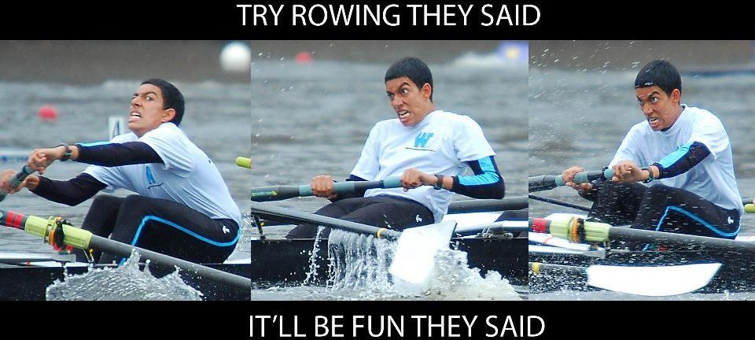

Remind 101

One more vital piece of information: You and your student athlete need to download the Remind App! This is the main source of communication between the Coaches and your rower/coxswain. It will keep you up-to-date on practice schedules, events, etc.
Sign up for Remind notifications by texting @thsrowing to 81010

Contacts

Coach | Email | Phone
Head Coach – Jeff Taylor | jefftaylorcrew@gmail.com | 734-771-6795
Assistant Coach- Mark Dolence | mdolence@comcast.net | 734-341-2064
Assistant Coach- Alex Pappas | Ampappas94@gmail.com | 734-250-5207
General Email | trentonvarsitycrew@gmail.com

Websites
Trentoncrew.com
Trentonathletics.com

Social Media Sites
Facebook: Trenton Crew
Twitter: @trentoncrew
Instagram: @trentoncrew

Links
Regatta Central- https://www.regattacentral.com/
USRowing- http://www.usrowing.org/
Row2K- http://www.row2k.com/
Rowing for Dummies- http://rowing-for-dummies.weebly.com/rowing/category/rowing-101#/

NOTES

